Darren Cosgrave

B00067349

Short Description

My aunty has her own side start up business in the field of beauty clinic. She would have beauty packages in the form of services (Make up and massages). She would also need to keep track of her regular customers and keep track of bookings times. Time permitting, she would also need to manage and keep track of her supplies.

ERD Diagram

Packages - pk = PackageId \\is it just packages?

Customers – pk = customerId

Bookings – pk = bookingId, fk_1= customerId, fk_2 = PackageId

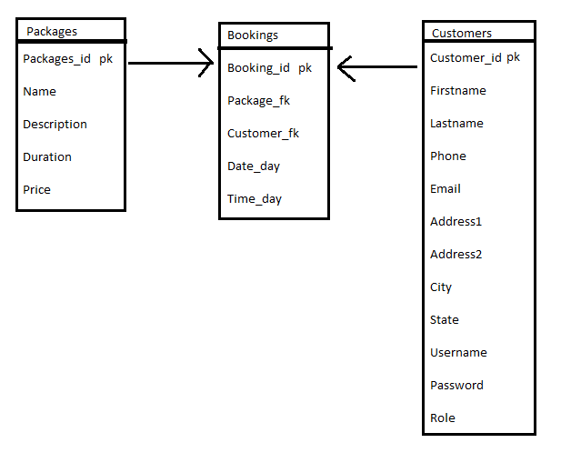

Description of Architecture Mapped

For this assessment I created three controllers, bookingsController, customerController and packageController. In these controllers I created an instance of the @EJB for the followning controllers.

bookingControler

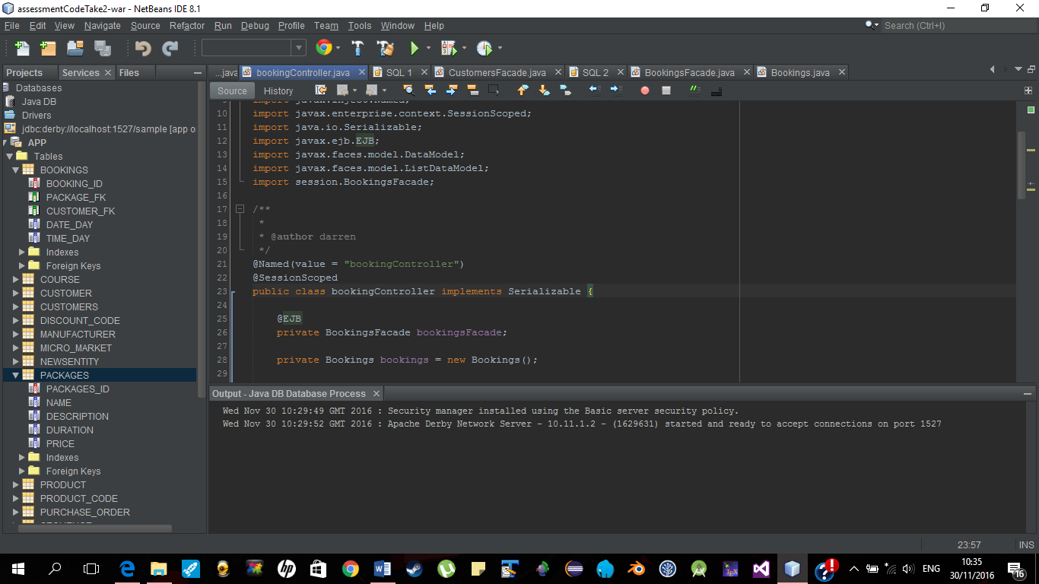

customerController

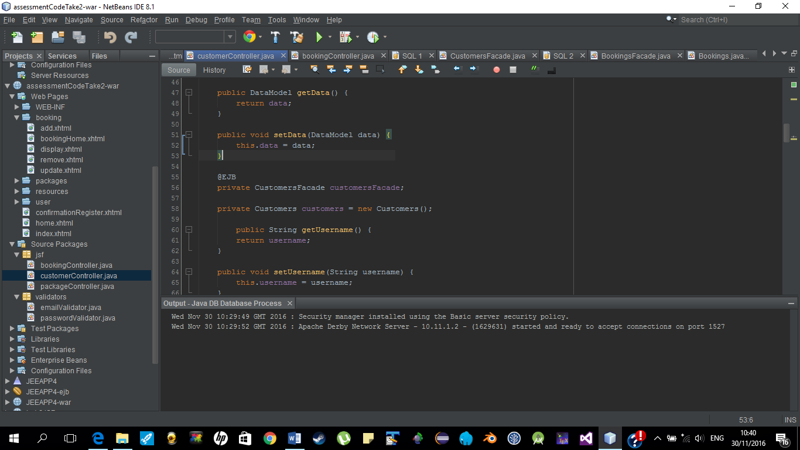

packageController

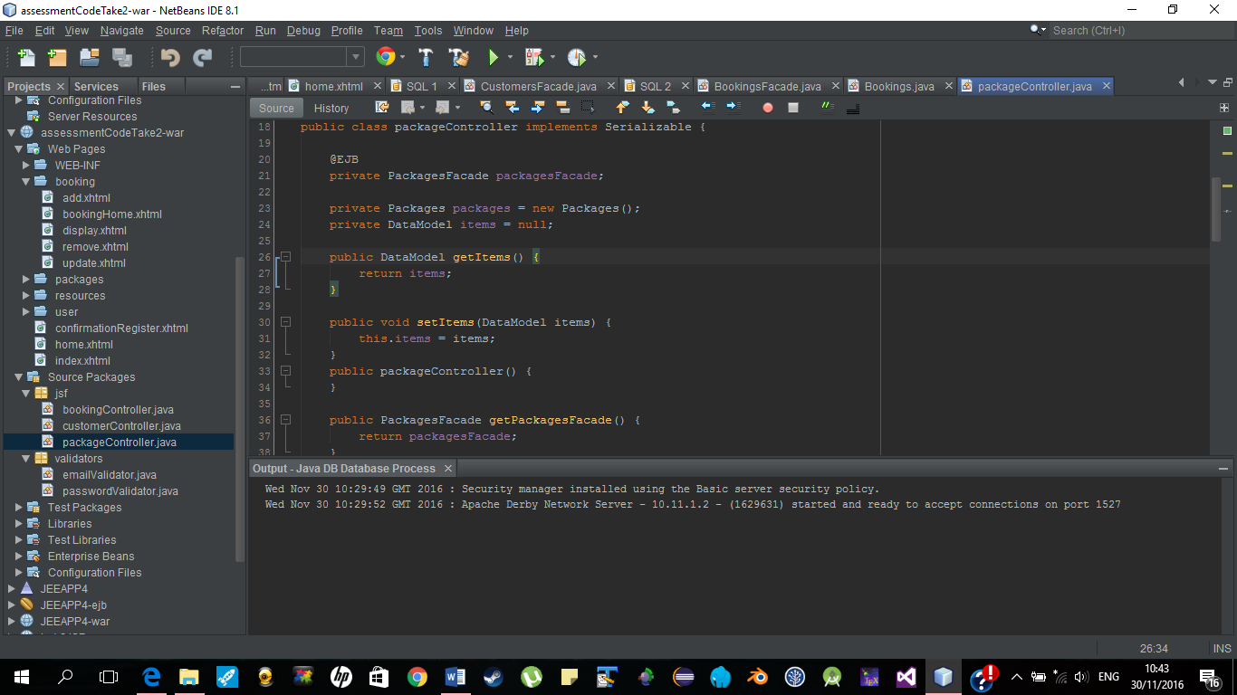

When the user registers on to the site, their data is sent to the customerController class which is then sent to the customer entity class. In side the customerController there is an instance of the customerFacade class. With this instance you can use the auto generated CRUD oprations. Where for me it would be “this.customersFacade.create(this.customers);” this line of code will add the user to the database with all their information.

Sometimes the auto generated CRUD oprations wouldn’t work for me so I had to make my own in the façades. With this assessment I had to start over a good few times as I was getting server, sql and EJB errors. When I took out the code that I just put in, the same error will still be there.

This method will valadate the username and password to see if the user is on the database. If yes this will return true, which will then bring them to the homepage with the help of the customerController. If false the customerController will return the user to the index with an error message.

The controllers are used to add, remove , update and display information to the user. This stops the user from getting derict access to the CRUD.

The sessions are used for connections between the entitys and controllers. These will have methods used by the controller such as the CRUD and admin defined methods such as the get maxCustomers.

The entities are used to hold the lets say customer object. Where the entity will hold the customers name, username, password, email, address and so on.

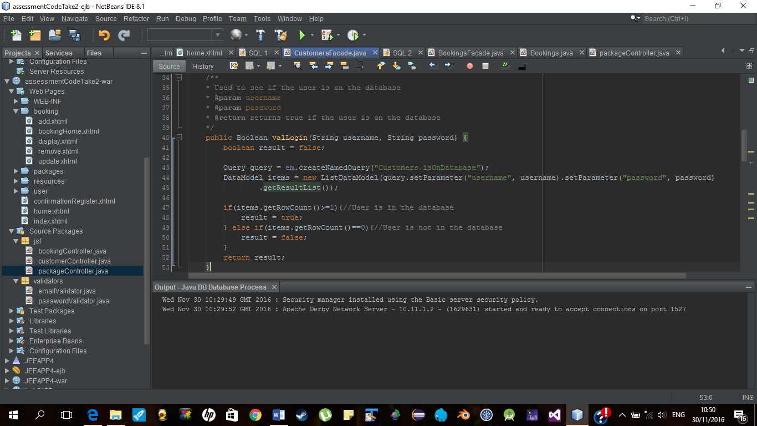

This method will return the max id, with this the customerController adds 1 and adds the user to the database. This method acts like an auto increment.

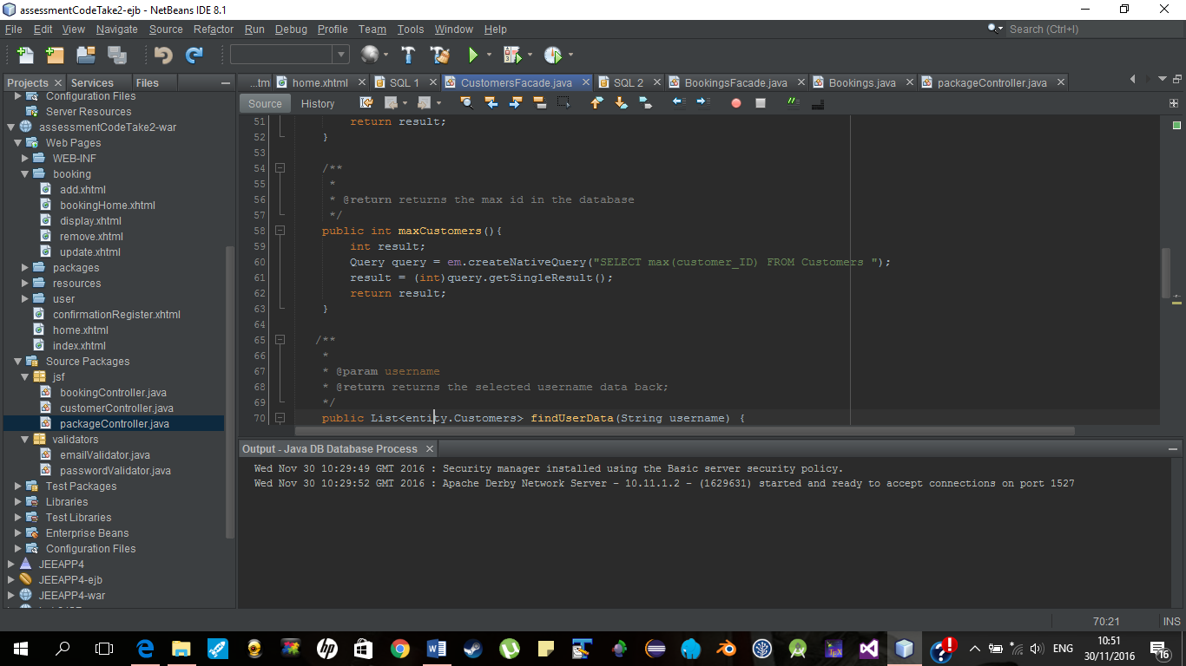

This method will get the users data from the database and return it back as a list;

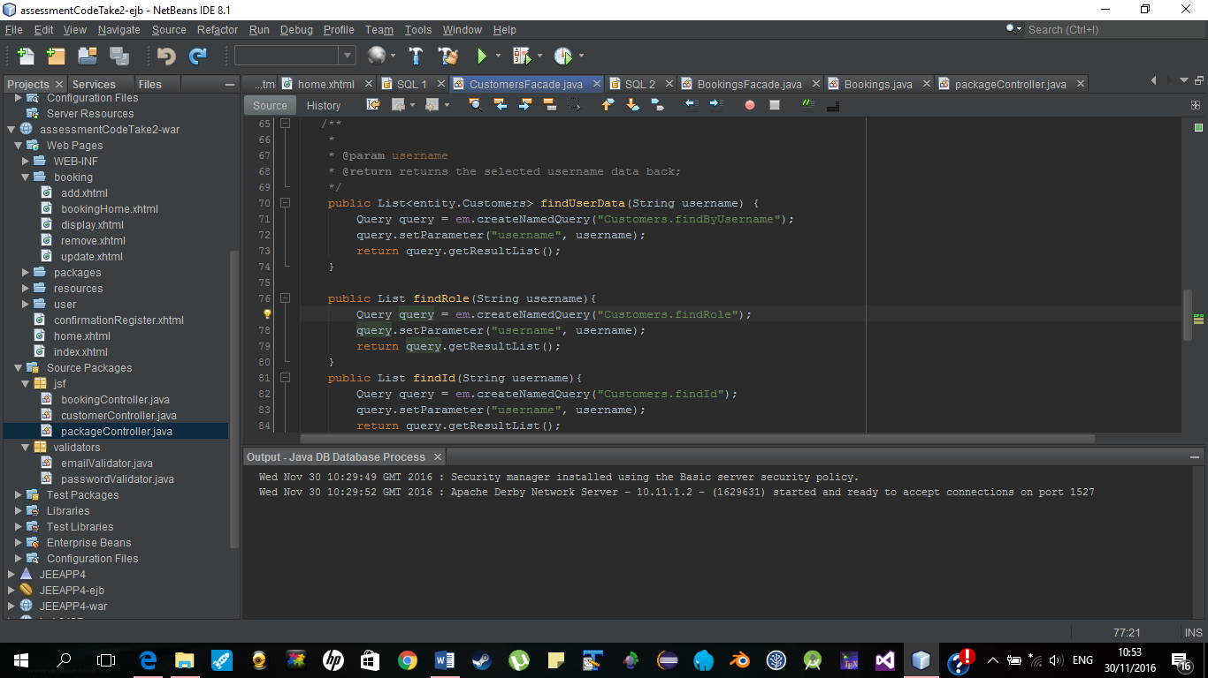

This code is used when the user logs in. Find role is used to set the users role in the customerController. This will stop a user accessing admin features such as the CRUD oprations for the packages. The find by id will be used for update and remove oprations for the CRUD user.

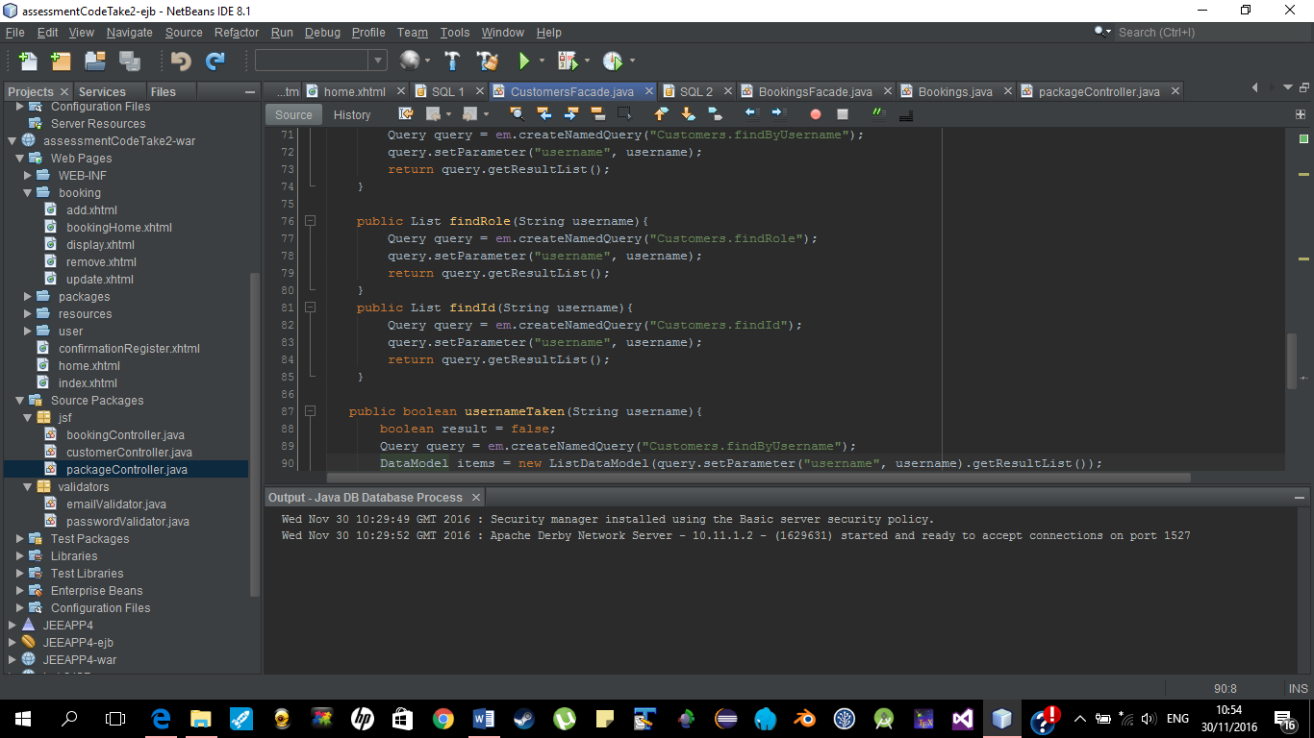

As you can see the user needs to be logged in to see the avabile options to them. This will also check to see if they are a user or admin. Only an admin can CRUD packages

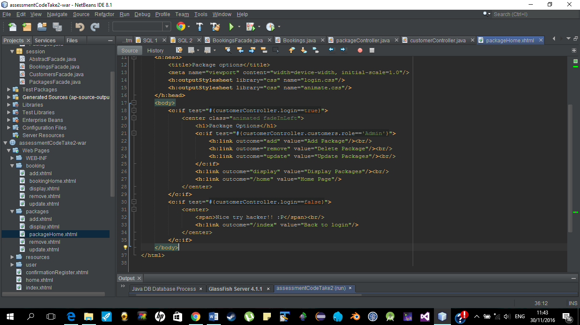

When a new user registers on, this method will check to see if the username is free or taken by an other user.

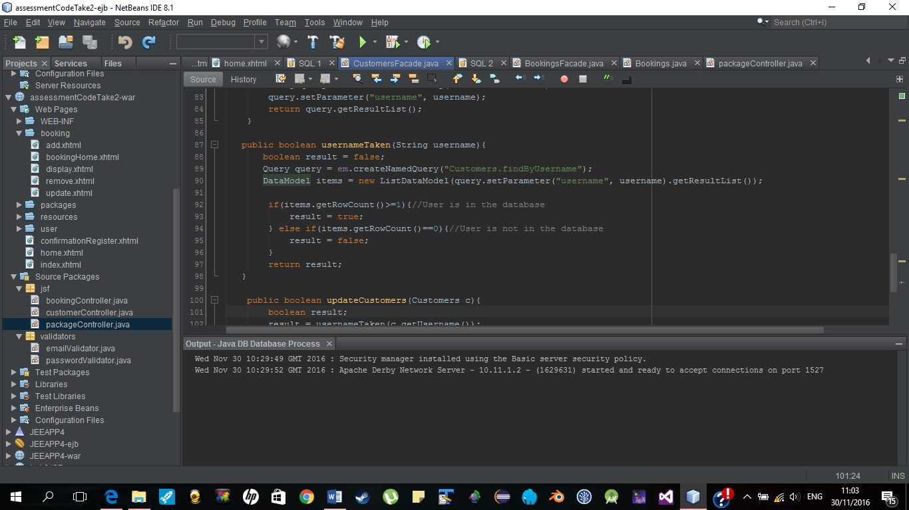

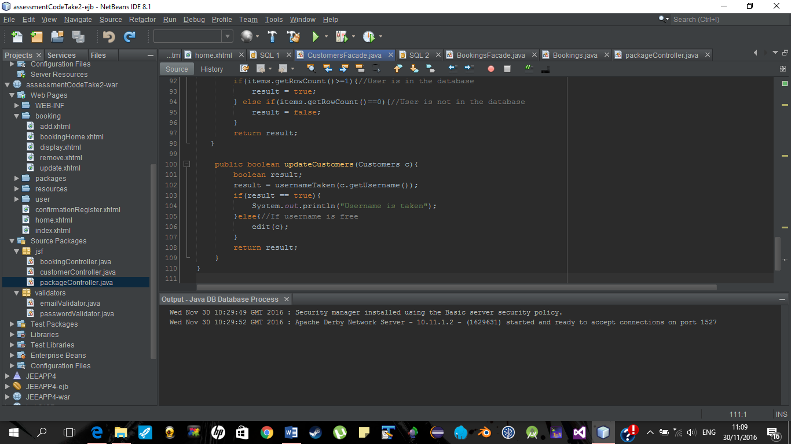

Max packages is getting the last id and adding 1 to it as to auto increment the id.

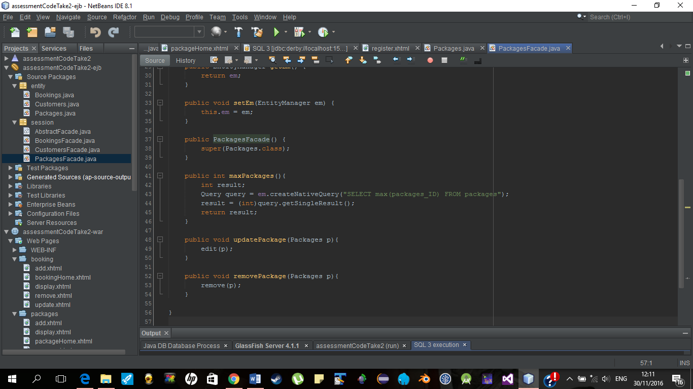

Diagram of Architecure

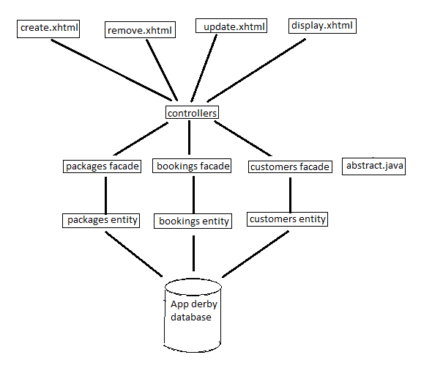

Screen Shots of user interface

Index.xhtml

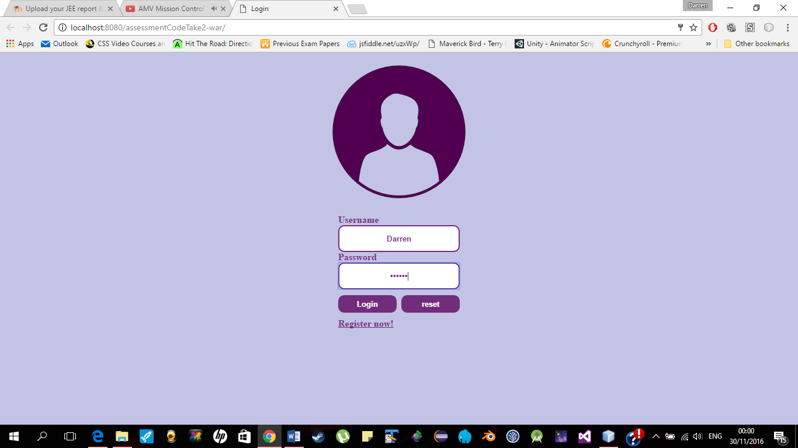

Register.xhtml

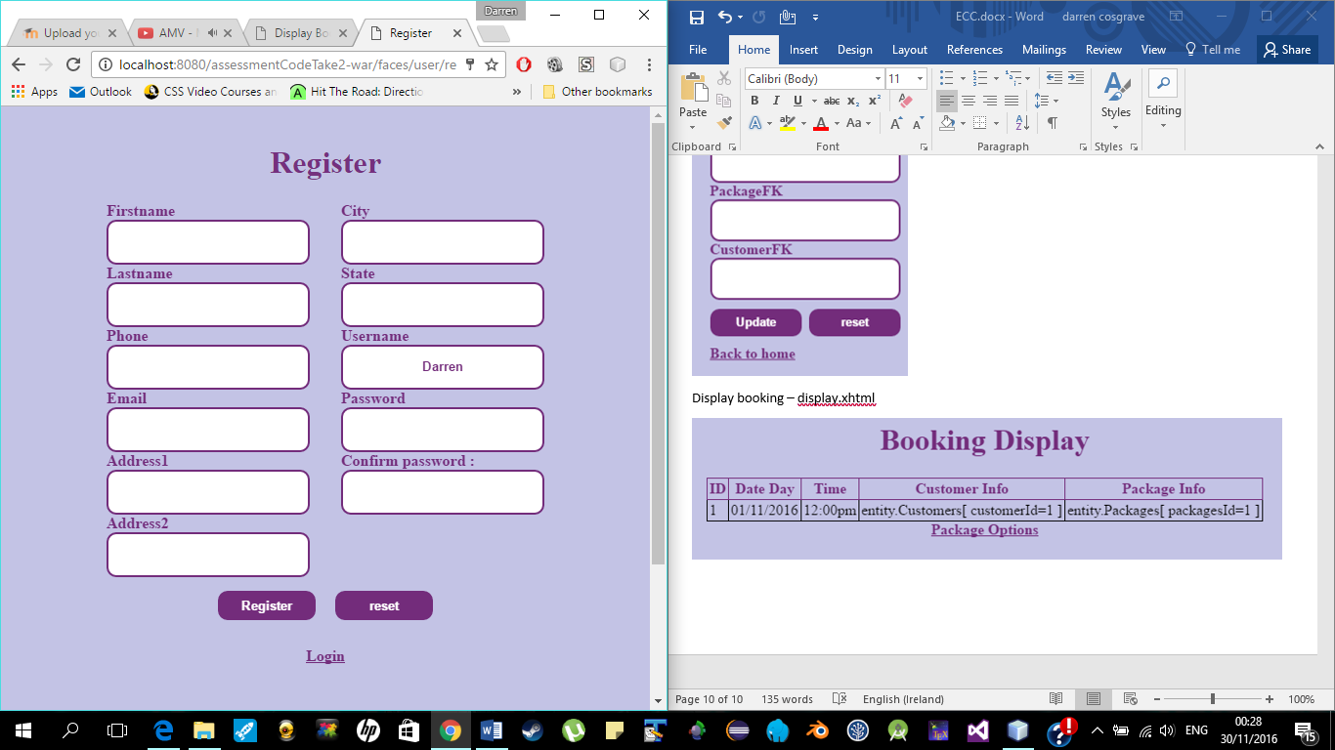

Home.xhtml

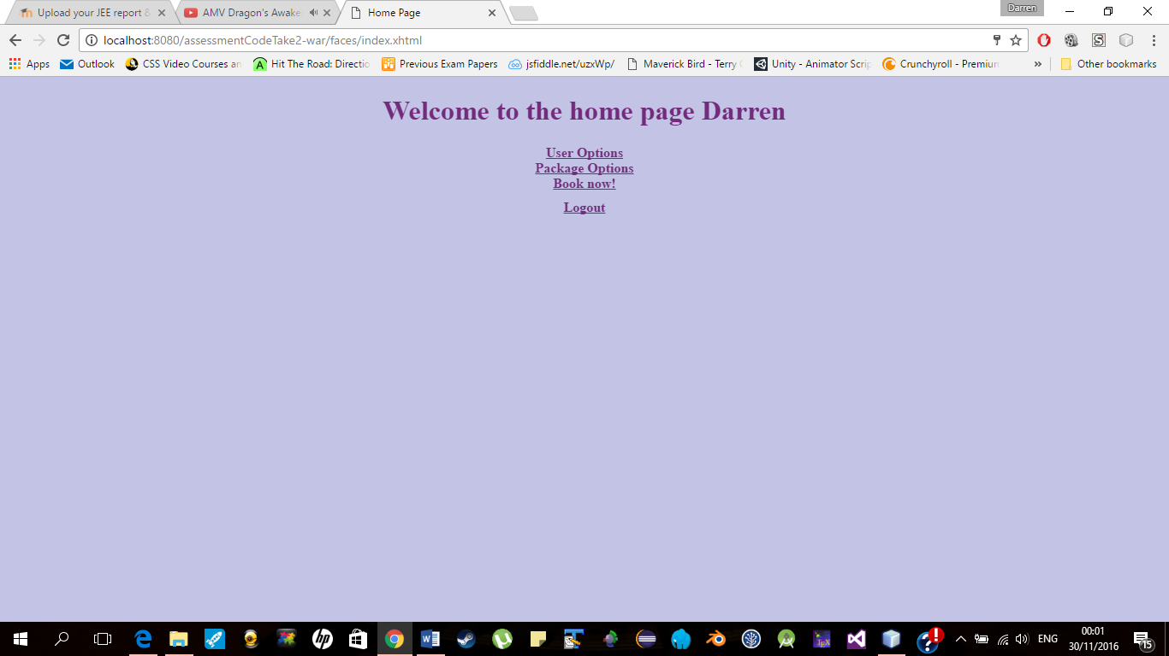

Admin view - userHome.xhtml

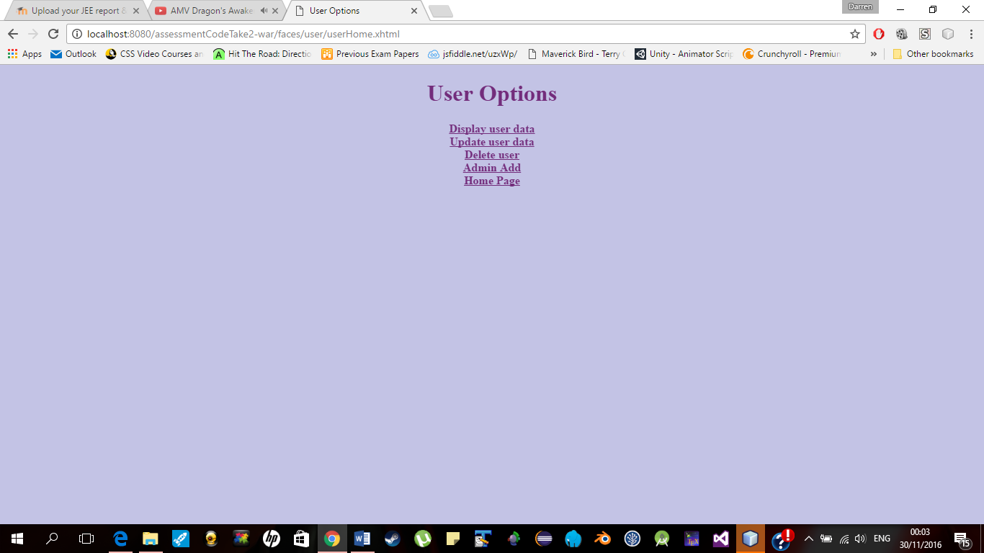

User view – userHome.xhtml

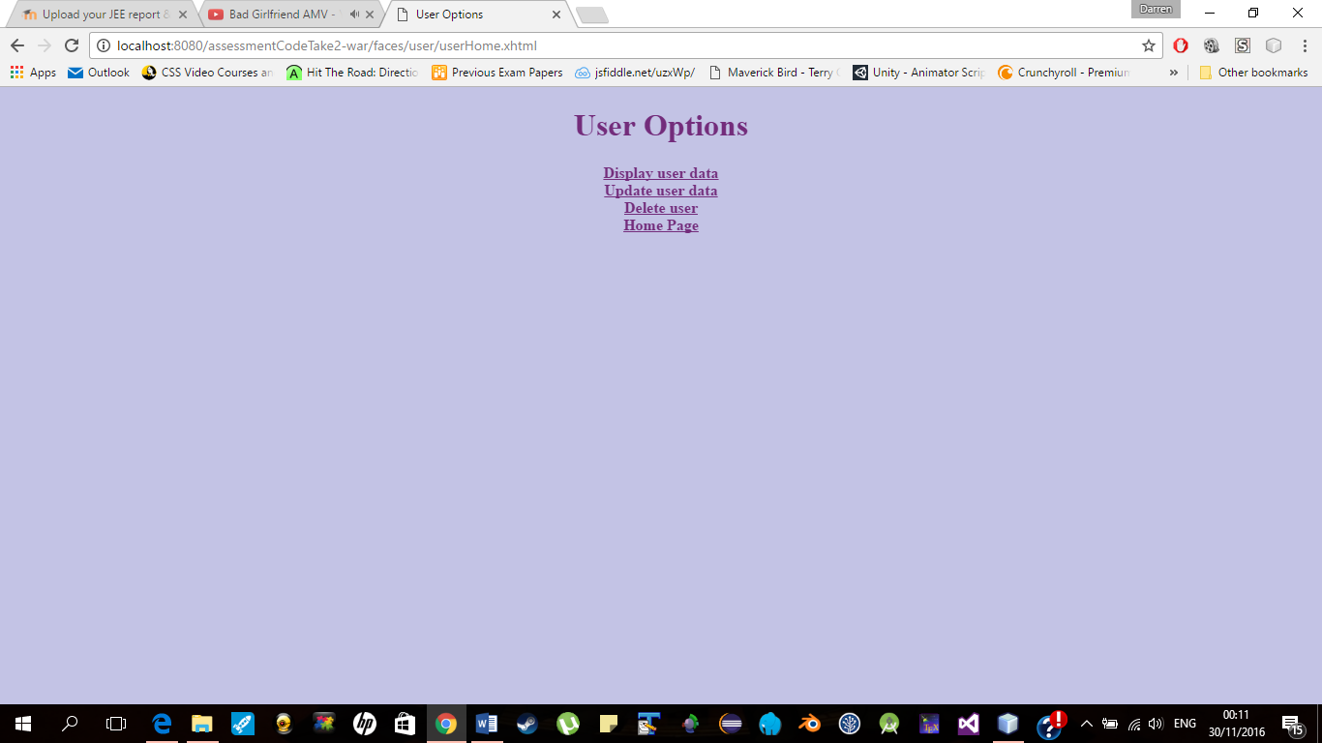

User display – display.xhtml

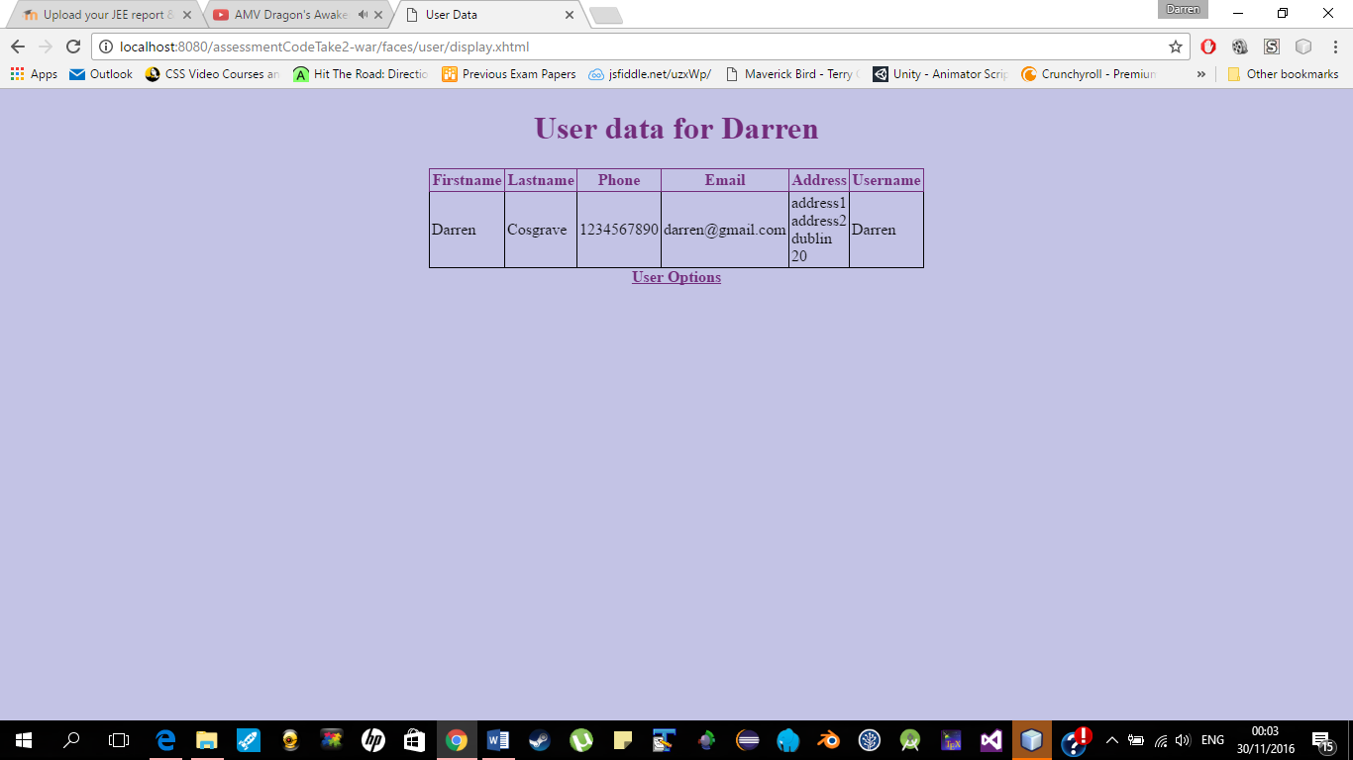

User update – update.xhtml

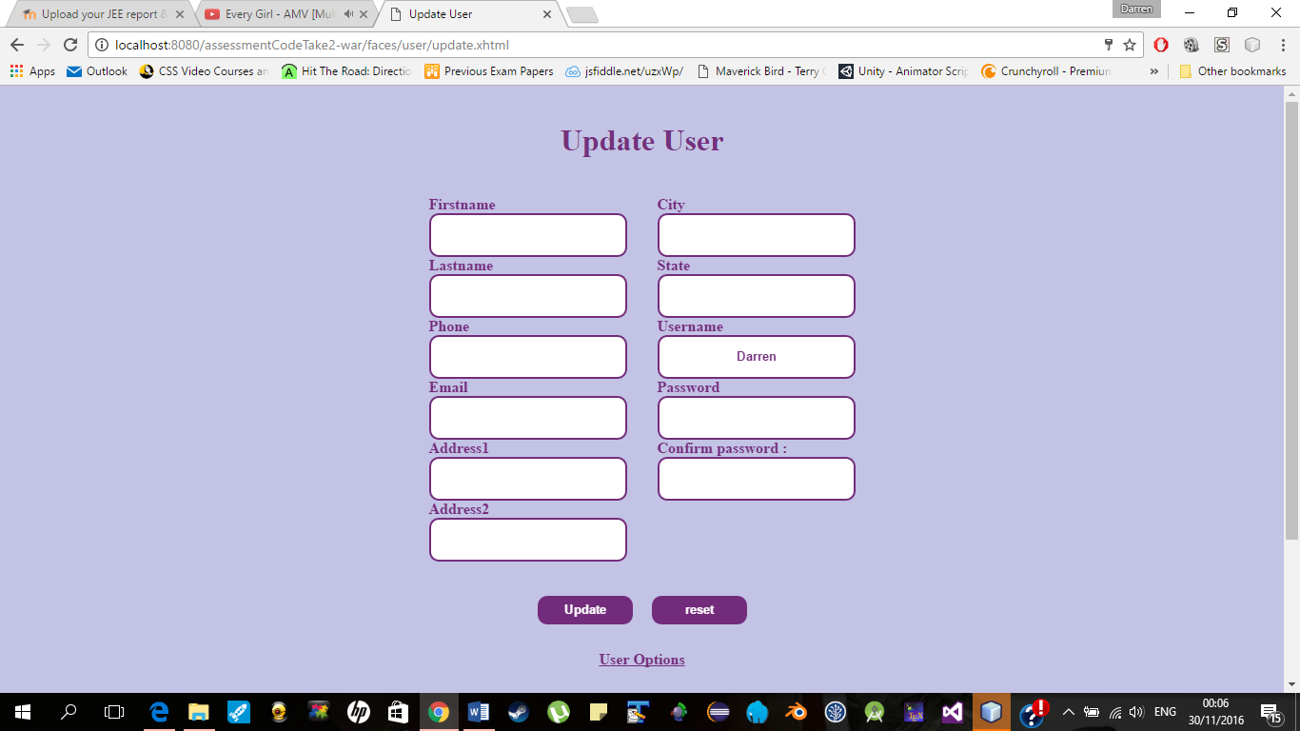

User remove – remove.xhtml

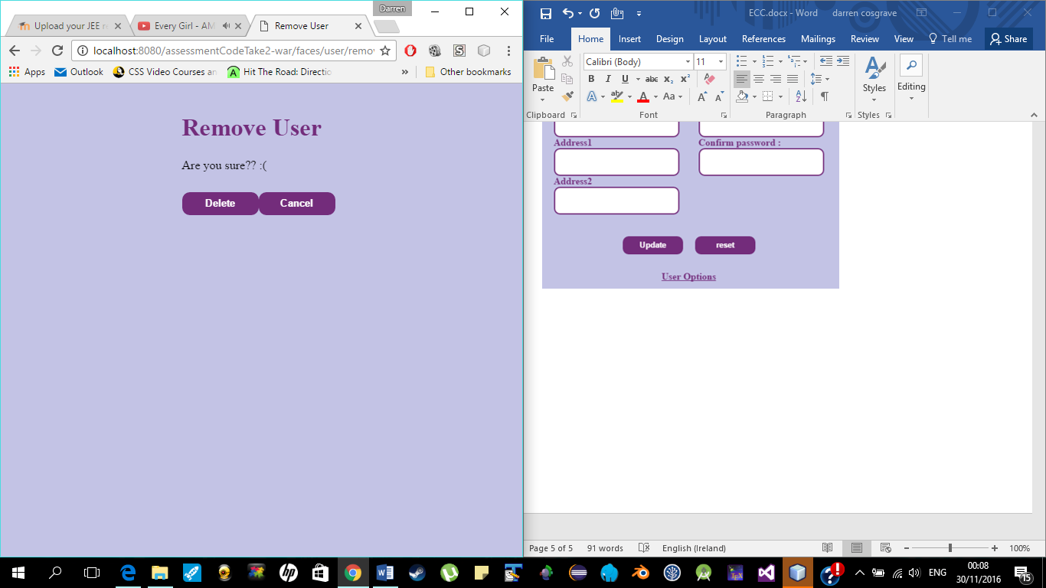

Admin add adminAdd.xhtml

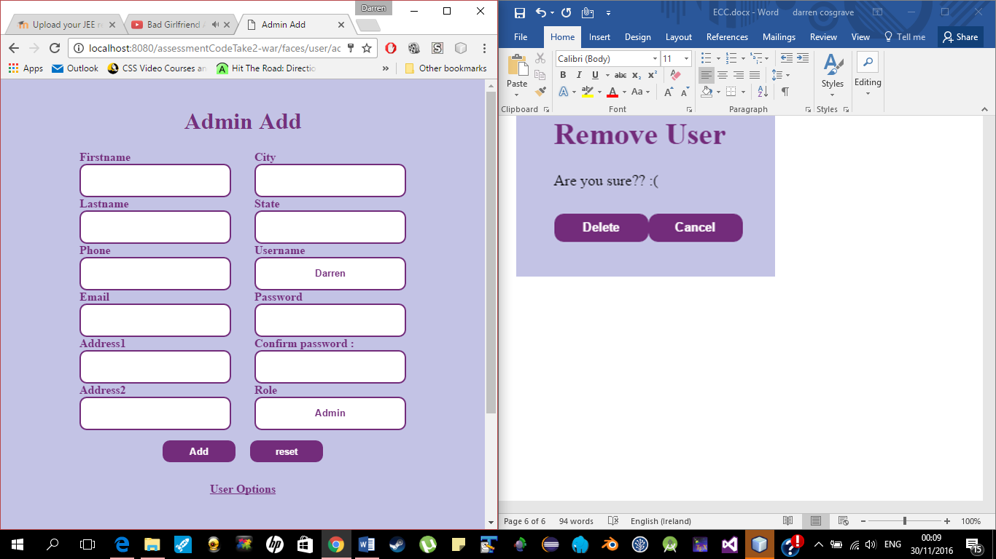

User view – packageHome.xhtml

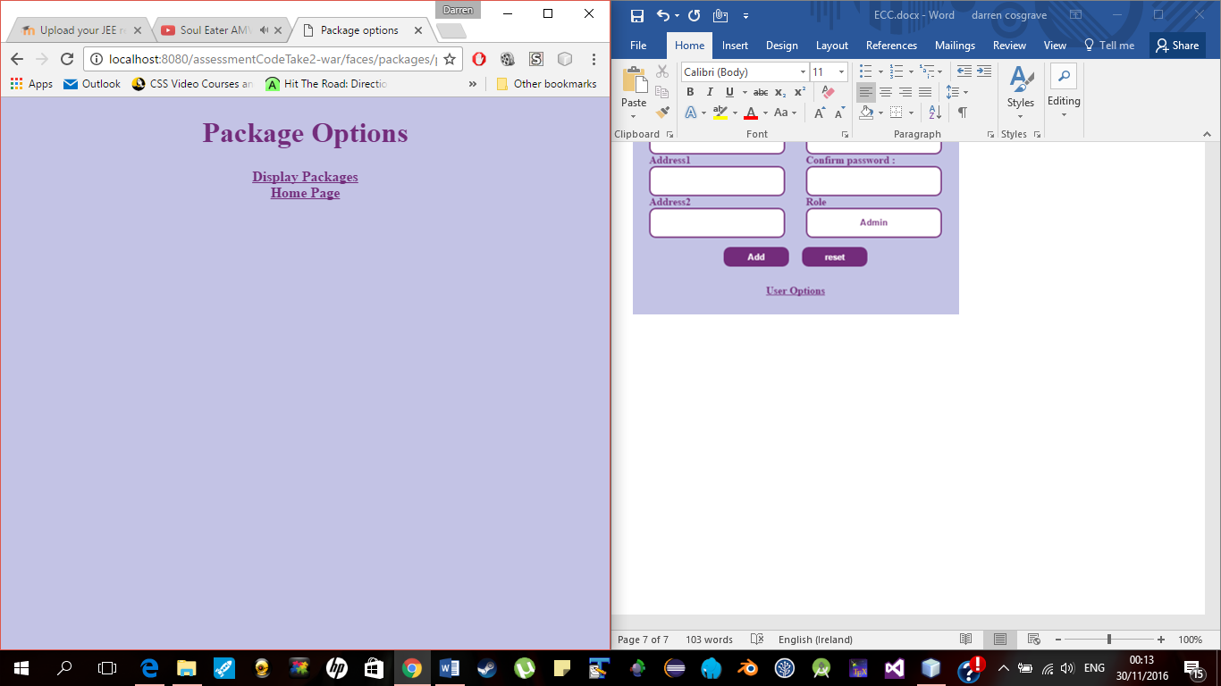

Admin view – packageHome.xhtml

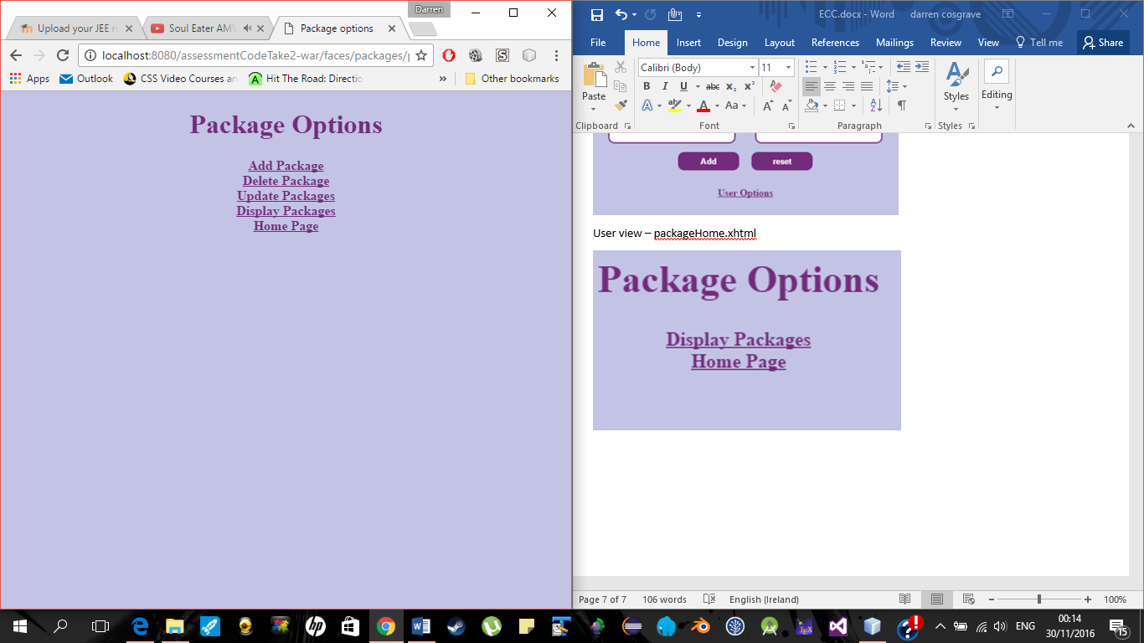

Amin Add package – add.xhtml

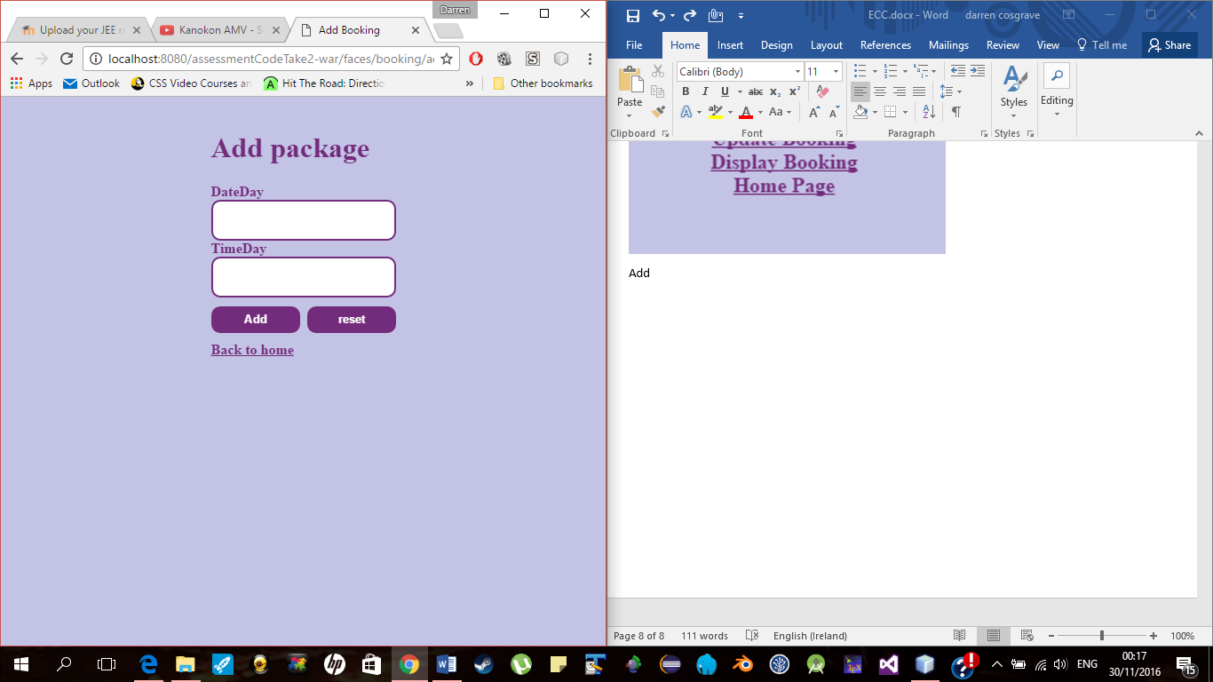

Admin remove package – remove.xhtml

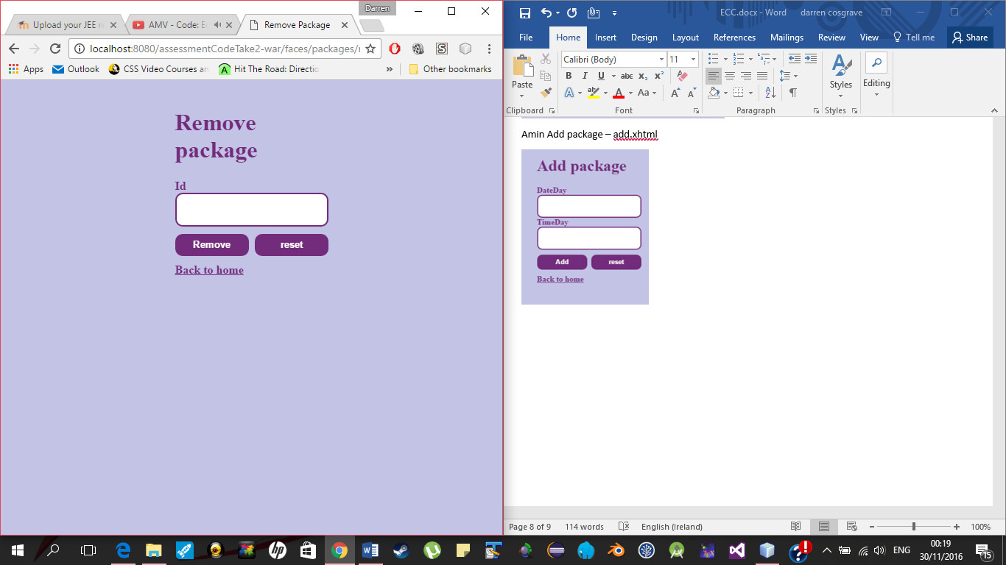

Admin update package – update.xhtml

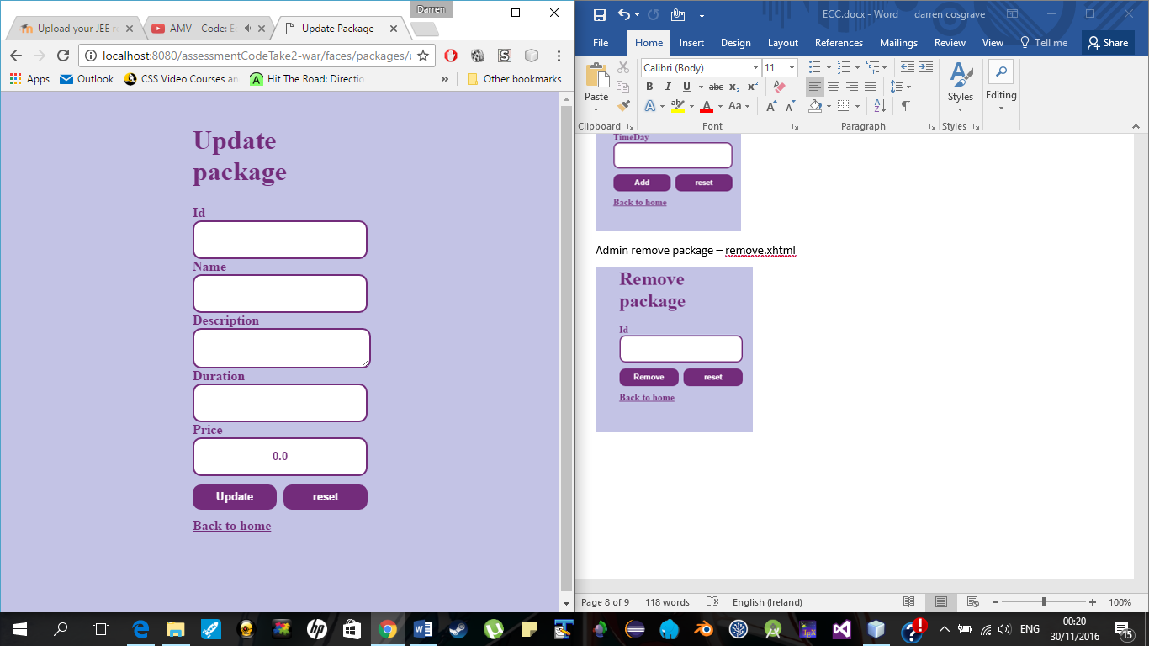

Admin display package – display.xhtml

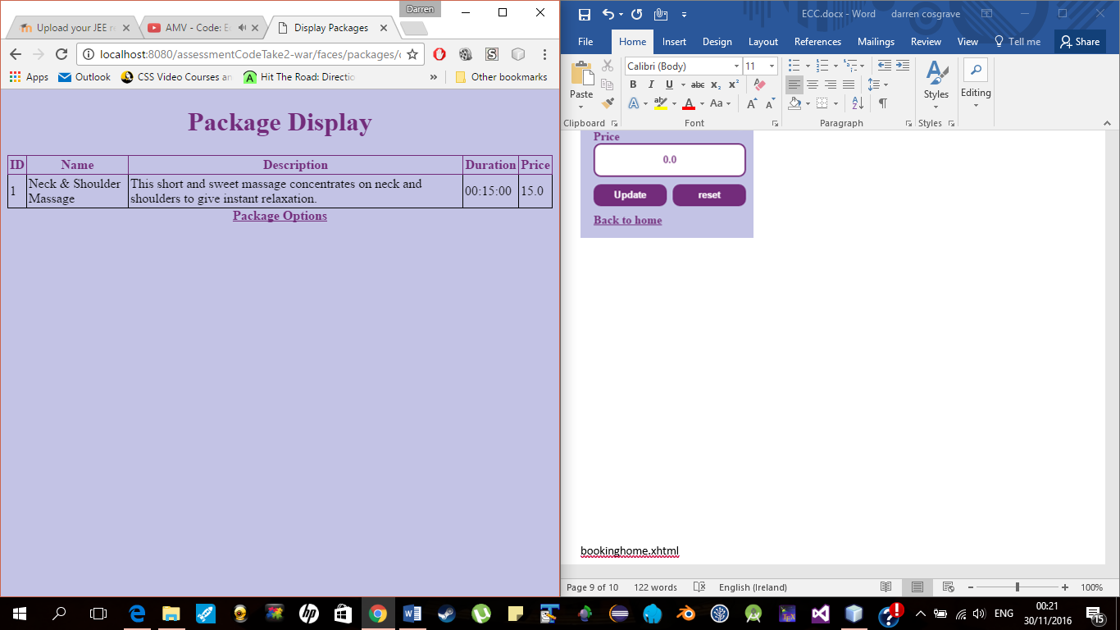

bookinghome.xhtml

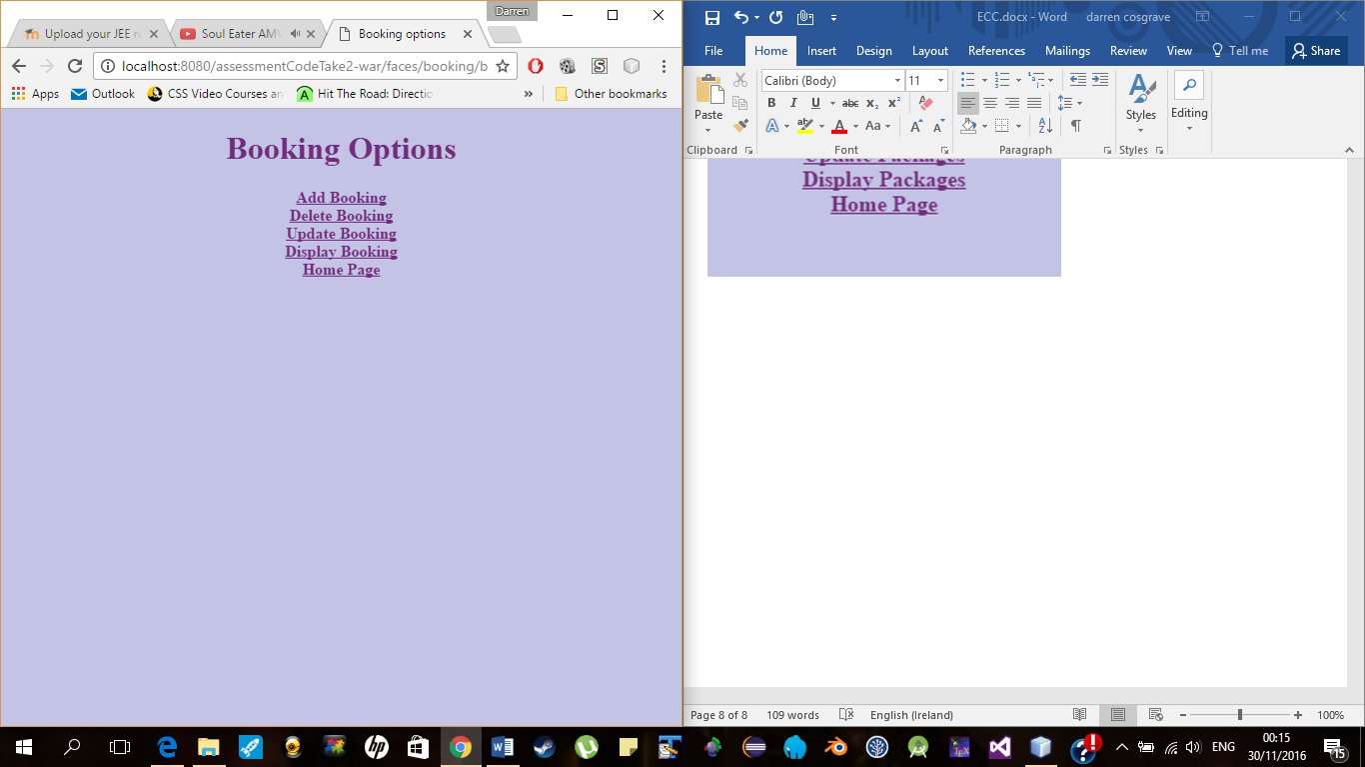

Add booking – add.xhtml

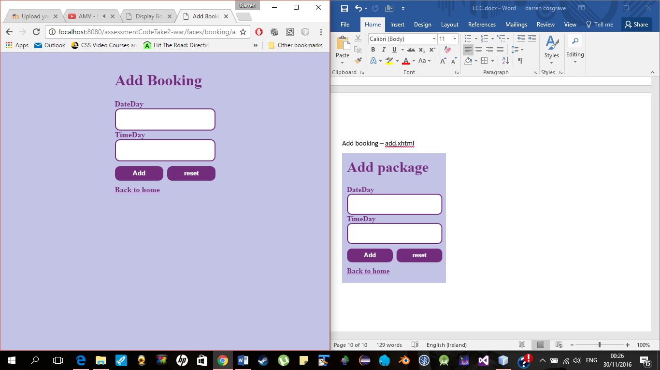

Update booking – update.xhtml

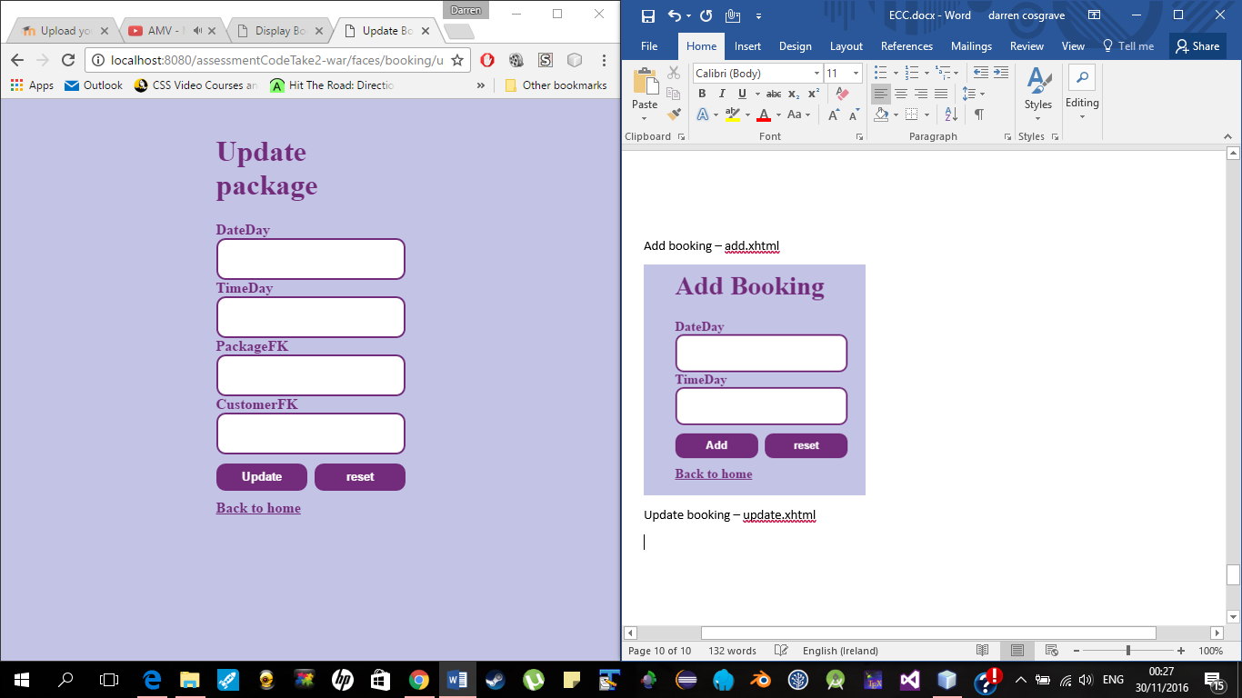

Display booking – display.xhtml

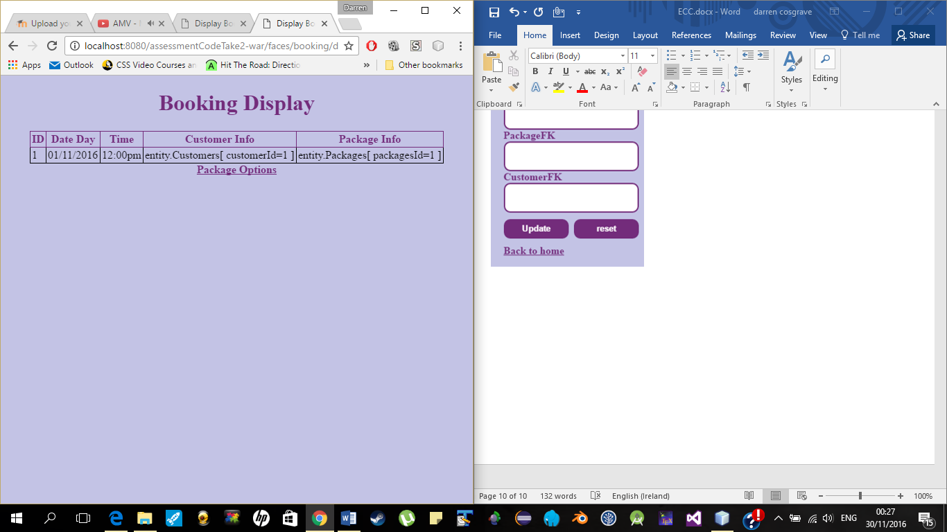

Walkthrough

On the index the user has to login to the site, if they try to go straight to the homepage or any other page bar the register, they will get a message saying that they need to login and will get a link to go back to the index. I know of glassfish has a security options built in, but for some reason I was getting server errors. So I made my own login security system. This will check to see if the user is logged in and if the user is on the database. When they login they are shown either user or admin options depending on their role stated in the database. With this only a admin can CRUD a package and only the current login user can remove themselves. If the user is not on the database they will need to register to the database. The register page will check to see if the email address is in the right format and will also check to see if the password and re password are the same. My CRUD operations for customer and packages and fully working but I couldn’t get the CRUD operations working for booking, as I didn’t realise that it was looking for an instance of the package and customer entities. In the booking add I was trying to get all the packages to dynamically show and not to hard code it. I was using the following code to try and achieve this. 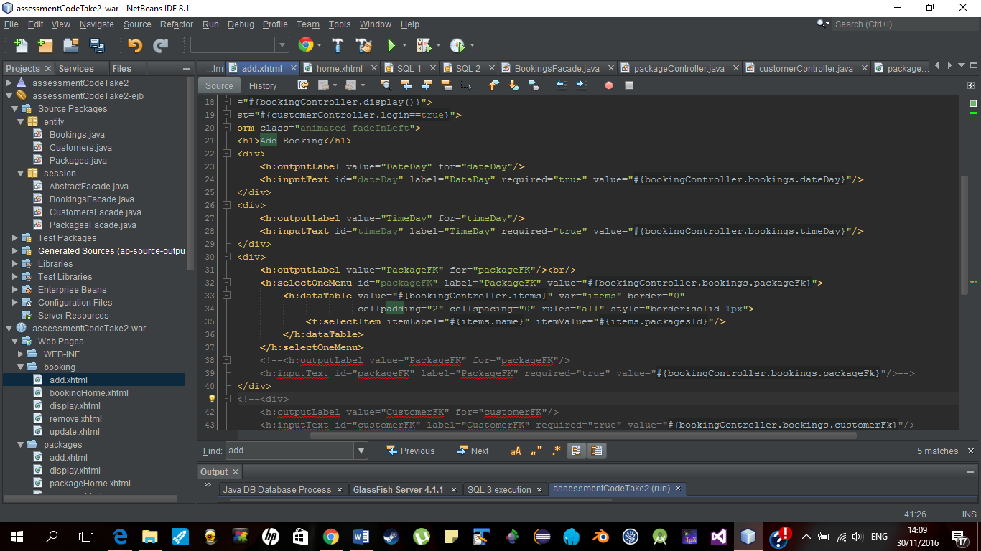

Errors that I have had in this assessment were EJB, server and sql problems. The CRUD operations in the abstractFacade where not working for me, so I made my own to fix the problem. I think I got this error due to the auto increment command was not working for the database table. So I made my own Maxpackage method to help with this as seen above it gets the max id and the controller adds one to the max so that its auto incrementing the id. When I was testing new code I got errors, I then removed that new code and clean build it but yet I was still getting the same error. With this I had to make a new project a good few times. This slowed me down as the project was still retaining information from the previous build.

Conclusion

Giving more time I would have tried to get the booking CRUD operations done and fully working. I would have also tried to get the packages to show dynamically in a dropdown feature on the booking add, where the user could pick the name of the package that they wanted.